Kirchhoff’s Laws

Equipment Needed

Power Supply, Fisher-EMD S44175-1 Battery Eliminator
Resistance Board Clear Plastic
Lead Set, Lab Tables
Multi-Meter, Digital (DMM) WaveTek 15XL
Probes, for Multi-Meter, Digital

Introduction
In this lab we will explore the consequences of Kirchhoff’s Laws for electric circuits for the case of three circuits. Our approach will be to predict every quantity we can, and then measure that quantity. Then we will compare the measured and predicted values.
Kirchoff’s Laws provide tools with which we can analyze complicated circuits. With the benefit of hindsight, we realize that they are equivalent to statements of conservation of energy and charge. Kirchhoff’s Current Law is illustrated in Figure 1. It states that the algebraic sum of the current at a junction point (a node) is zero. This means that the total current flowing into a point equals the total current flowing out. In Figure 1, Kirchhoff’s Current Law would be expressed
where
.
We can understand the equivalence of Kirchhoff’s Current Law to the law of conservation of charge with the following heuristic argument. Imagine that the current entering the node was less than that exiting it. Since current is the rate of flow of charge, this would mean that more charge was leaving the node than entering it. Thus charge would have to be created at the node, violating conservation of charge. In order for the node to not act as a source (or a sink for that matter) of charge, Kirchhoff’s Current Law must hold.

This can be demonstrated:
Figure 1: Since is coming into the node it is a positive quantity. and are leaving the node, so they are negative. Thus, Kirchoff’s Current Law yields
Or
.
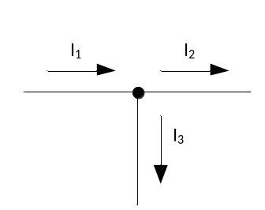

Figure 2 illustrates Kirchhoff’s Voltage Law. It states that the algebraic sums of the potential differences around a closed loop is zero. Put another way, the sum of the potential gains equals the sum of the potential drops. For the circuit shown in Figure 2 where
And
,
Kirchhoff’s Voltage Law yields
or equivalently
We can see the equivalence of Kirchhoff’s Current Law to conservation of energy by following a charge Q around the loop. Since the electric force is a conservative force, if the charge makes a complete trip around the loop it must end up with a net change in energy of
Adding up the energy gains we obtain,
Adding up the energy losses we obtain
The net change in energy around the loop is
If we simply divide by Q, we obtain Kirchhoff’s Voltage Law.
Figure 2 Kirchhoff’s Voltage Law applied to a single loop yields
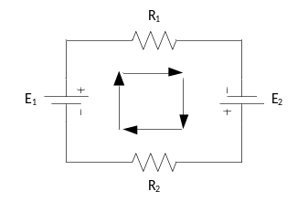
The arrows in the center of the ring indicate Current flow.
We will now examine how these laws apply to some real circuits.
Procedure
We will examine three circuits, which we will construct by connecting the three resistors on the circuit board in different ways.
First, before making any connections, use the DMM to measure the value of each of the resistors. It is important know the identity of each resistor before wiring into the circuit. Record the values as , , and . The measured values are the ones you will use in your calculations.
Second, measure the output voltage of the battery eliminator and record.
Resistors
 | Nominal Value | Measured Value
 | 100Ω
 | 330Ω
 | 560Ω
Battery Eliminator
 | 6VDC
For each of the following circuits, do the following (show your work):
- Calculate the equivalent resistance using the measured values of the resistors.
- Measure the equivalent resistance. Remember, this must be done without the battery eliminator in the circuit.
- Calculate the predicted current through each resistor using the measured values of the resistors and the measured value of the battery eliminator.
- Measure the current through each resister.
- Calculate the predicted potential difference across each resistor using the measured value of the battery eliminator.
- Measure the potential difference across each resistor.
Here are a few pointers to help you accomplish these objectives:
- The equivalent resistance is measured by simply measuring with the DMM across the network.
  - Always measure resistance with the resistors NOT connected to the power supply. If the resistors are connected to the power supply, then capacitance and resistance in the power supply as well as current flowing in the circuit can greatly skew your readings.
  - The leads must be plugged into the Ω and the COM plug respectively.
  - For measuring resistance the meter dial should be set in the 2kΩ range.
- The potential difference across an element can always be measured by placing the probes of the DMM across the two sides of the element.
  - The leads must be plugged into the V plug and the COM plug respectively.
  - For measuring potential difference the meter dial should be set in the 20VDC range.
  - Note: For calculated values use the measured potential at the battery eliminator.
- A conventional ammeter must ALWAYS be placed in series with the element through which you wish to measure the current.
  - The leads must be plugged into the 200mA plug and the COM plug.
  - For measuring amperage the meter dial should in the 200mADC range.
  - Unlike the voltage measurement the ammeter will have to be moved and inserted into the circuit specific to each leg to be measured. If you have trouble with this your instructor or lab tech can help.
  - Do Not turn on the circuit until it is checked by your instructor or the lab tech. Failure to wire the ammeter properly can blow the fuse in the ammeter rendering it unusable for the rest of the lab.
- We will use the battery eliminator set at the nominal voltage 6VDC. Be sure to measure the actual voltage.
Circuits to construct, analyze, and measure
Circuit Number 1
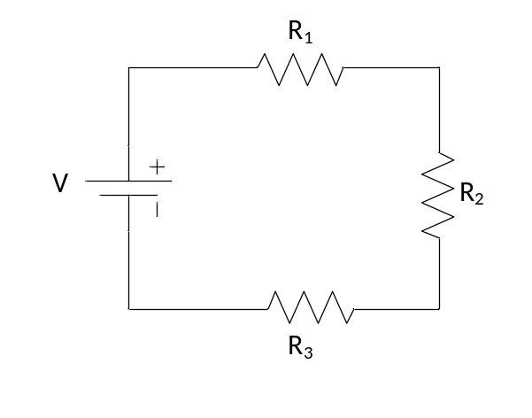
Circuit Number 2
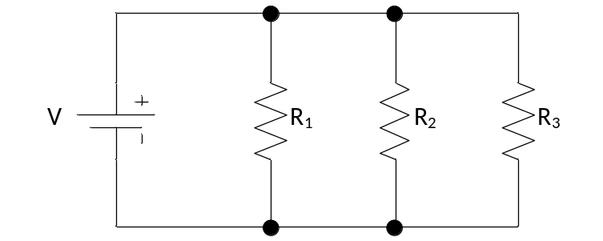
Circuit Number 3
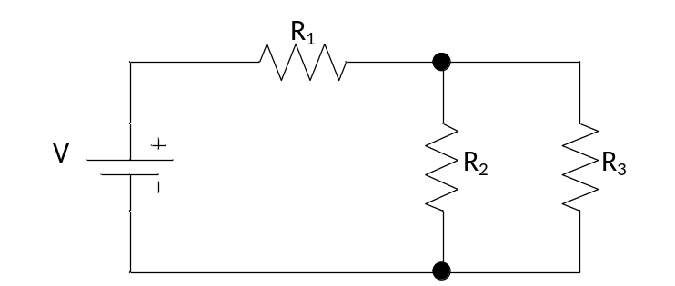

Report Format
- Your report should consist of three pages, with one page corresponding to each of the circuits.
- Each page should include a schematic of the circuit and a very neat and clear theoretical analysis of the circuit.
- In a table on each page you should list your calculated values and your measured values.
- Note: Include a column for percent error calculated between theoretical and experimental.
- Discuss possible sources of any systematic error.

